Prescribed and Wildland Fire Use on the Orleans Ranger District 1958-2015
Jake Shuler
26th April 2016

Abstract
Prescribed fire is quickly grabbing the attention of the public and forestland managers as a useful tool. It can be used to successfully clear heavy fuel loads, prevent the event of a catastrophic wildfire, clear brush, increase nutrient availability, and keep forests healthy to a variety of forest related diseases. The Orleans Ranger District has been using fire as a tool since the late 1950’s. This paper focuses on the types of fires that have occurred on the Orleans R.D. from 1958 to 2015. Each type of burn is mapped below with the number of acres burned associated with it.

Introduction
The Orleans Ranger District (ORD) is located in Northern California on the Six Rivers National Forest and encompasses approximately 500,000 acres of forestland near the Pacific Ocean. Its boundaries extend north into Del Norte and Siskiyou County and south into Humboldt and Trinity County (Figure 1).
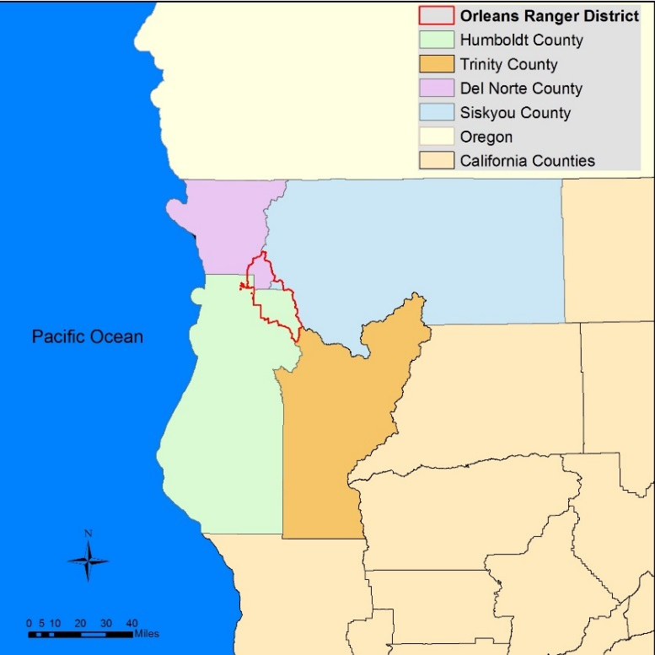
Figure 1. Orleans Ranger District Relative California Counties, specifically to Humboldt, Del Norte, Siskiyou, and Trinity Counties.
In this area, fire has played a critical role throughout time in maintaining ecosystem balance. It was used by the Hoopa, Yurok, and Karuk tribes as a tool for maintaining open hunting grounds and keeping grubs out of acorns for human consumption. When European settlers moved into the area in the mid 1800’s for the purpose of mining / logging, they looked at the use of fire as a threat to their natural resources. Thus, began the realm of wild land fire suppression. It wasn’t until the late 1950’s when the US Forest Service started looking at the use of fire as a forest management tool.
Prescribed fire (also called controlled burning) is an important tool that can be used to reduce the risk of large uncharacteristically severe wildfires, increase public and firefighter safety, as well as meet a variety of integrated natural resource management objectives. (Prescribed Fire) This report displays the type of burns that were performed and how many acres each type of burn encompassed on the Orleans R.D. Types of burns include: burning of piled material, jackpot burning, site preparation burn for planting, low intensity under burn, wildfire fuels benefit, wildfire human ignition, and broadcast burning. These burns range from the year 1958-2015.
Burning of piled material is exactly as it sounds, it involves thinning the forest of brush, debris, and small diameter timber, piling it up and burning the piles in the spring or fall. Understory burning/under burning involves a prescribed fire ignited under the forest canopy that focuses on the consumption of surface fuels but not the over story vegetation. Under burning is generally used following a pre-treatment such as thinning and / or pile burning to further reduce the surface fuels, help maintain the desired vegetation conditions and enhance the overall health and resiliency of the stand (Prescribed Fire). Broadcast burning is a type of prescribed fire ignited in areas with little or no forest canopy present. Broadcast burning is used in grasslands, shrub lands, and oak woodlands for habitat restoration and fuels reduction purposes. This type of burning can be beneficial for protecting and enhancing sage grouse habitat and deer and elk winter ranges. Jackpot burning is a modified form of an under burn or broadcast burn where the target fuels to be ignited are the concentrations (or jackpots) of vegetative fuel. The result of a jackpot burn is a mosaic burn pattern. This technique works well when surface fuel loading is very high following vegetation treatments such as Douglas-fir encroachment into oak woodlands (Prescribed Fire). Site preparation burn for planting is the process of burning understory brush, surface litter / duff, to prepare and open a specific site for the planting of trees. Wildfire fuels benefit is when a wildfire starts from natural causes (e.g. lightning) and is allowed to burn for the benefit of getting rid of forest fuel loads. Wildfire human ignition is a wildfire started because of a human (e.g. arson, sparks created from dragging chains, chainsaw, etc.). This type of wildfire is usually suppressed immediately because it benefits no management objectives within the forest.

Methods
Jennifer Peterson, the Six Rivers National Forest Global Information Systems (GIS) Specialist, was first contacted through e-mail regarding fire history on the Orleans R.D. She was able to e-mail a number of shapefiles including a shapefile of the Six Rivers National Forest and one of Prescribed and Wildland Fire history from 1958-2015 on the Orleans Ranger District. A shapefile regarding California Counties was then obtained from the California GIS website and a Landsat 8 image of the area around Orleans, Californai was obtained from United States Geological Survey (USGS) Earth Explorer website. Once all data was in procession, a Quality Assurance Quality Control (QAQC) form was filled out for each piece of data obtained. ArcMap 10.2.2 a GIS computer software program was used to create the necessary maps for this report. All data was loaded into ArcMap and projected using the projected coordinate system; North American Datum 1983 Universal Transverse Mercator Zone 10 North. Once all data was projected in this projected coordinate system, the “attribute table” for the Six Rivers National Forest shapefile was opened and by using the “Select by Attributes” tool, the Orleans R.D. was selected. From this selection a separate shapefile was created so that only the Orleans R.D. was displayed. Using the California Counties Shapefile, and the same process described above, Del Norte, Siskiyou, Humboldt, and Trinity Counties were selected and a separate layer was created so that the Orleans R.D. could be displayed on top of these counties (Figure 1). The Orleans R.D. shapefile was then displayed on top of a topographic base map so that the Hoopa and Yurok Indian Reservations were shown in relative to the Orleans R.D. (Figure 2). Once these two maps were created, the Orleans R.D. And Prescribed and Wildland Fire shapefiles were overlaid on top of the Landsat 8 image to display terrain characteristics of the area and the type of area each fire burned in (Figure 3). “Broadcast Burning” was separated from the other types of burns because it encompassed a greater amount of area (Figure 5). Also, to see the area burned in greater detail, the Orleans R.D., Prescribed and Wildland Fire, and Broadcast Burning shapefiles were displayed without the Landsat 8 image (Figure 4) and (Figure 6). A table was then created using Microsoft Excel to display the amount of acreage burned for each type of fire and the year performed (Table 1).

Results

The following maps and table display the results for this project. This includes the location and acreage of each burn from 1958-2015.

Table 1. Type of Burn and Total Acres Burned from 1958-2015 on the Orleans Ranger District.
Type of Burn | Number of Acres Burned  1958-2015
Jackpot Burning | 374
Broadcast Burning | 51,747
Burning of Piled Material | 2,341
Site Preparation Burn for Planting | 1,339
Underbury-Low Intensity | 2,880
Wildfire-Fuels Benefit | 39,481
Wildfire-Human Ignition | 318
Total | 98,480

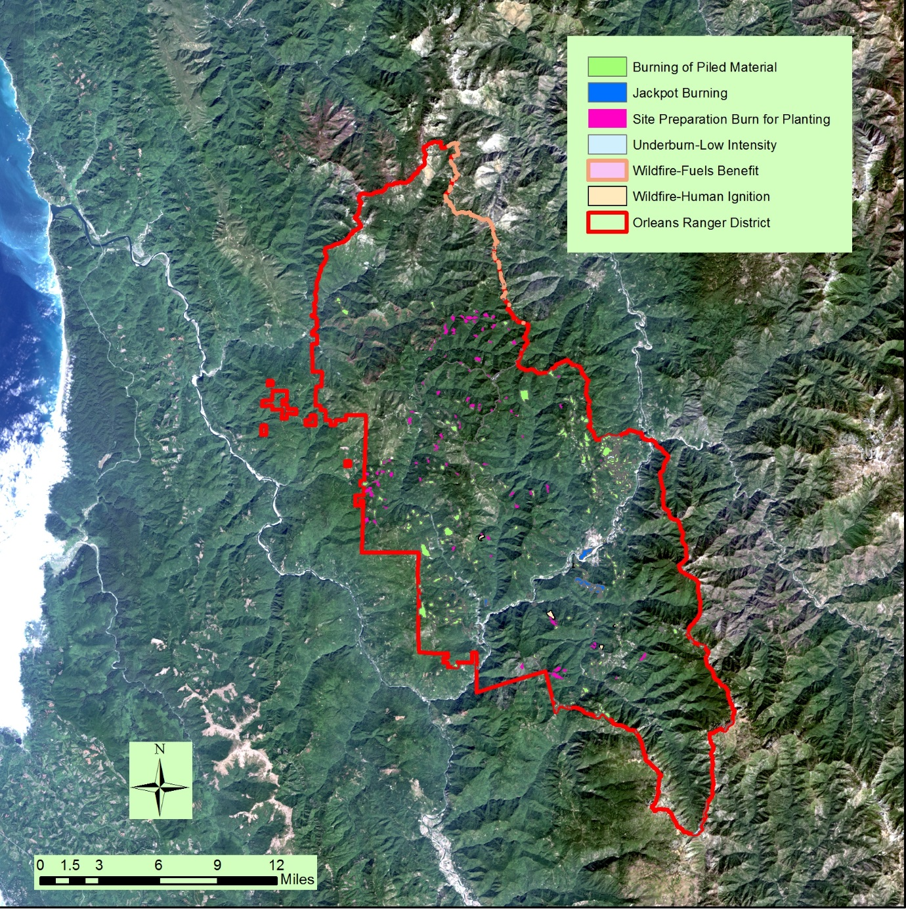
Figure 3. Map Showing Type of Burn and Location on the Orleans R.D. 1958-2015 Overlaid on Landsat 8 Image.

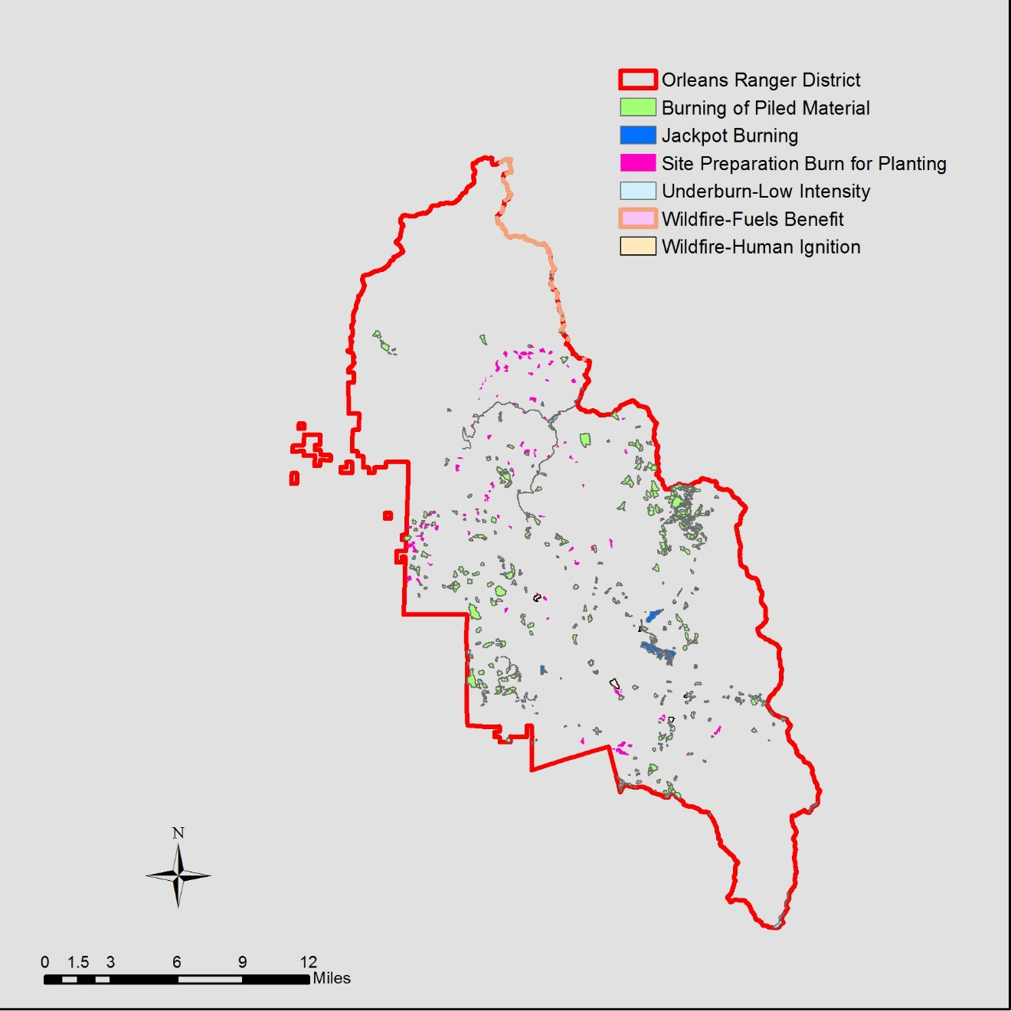
Figure 4. Map Showing Type of Burn and Location on the Orleans R.D. 1958-2015.

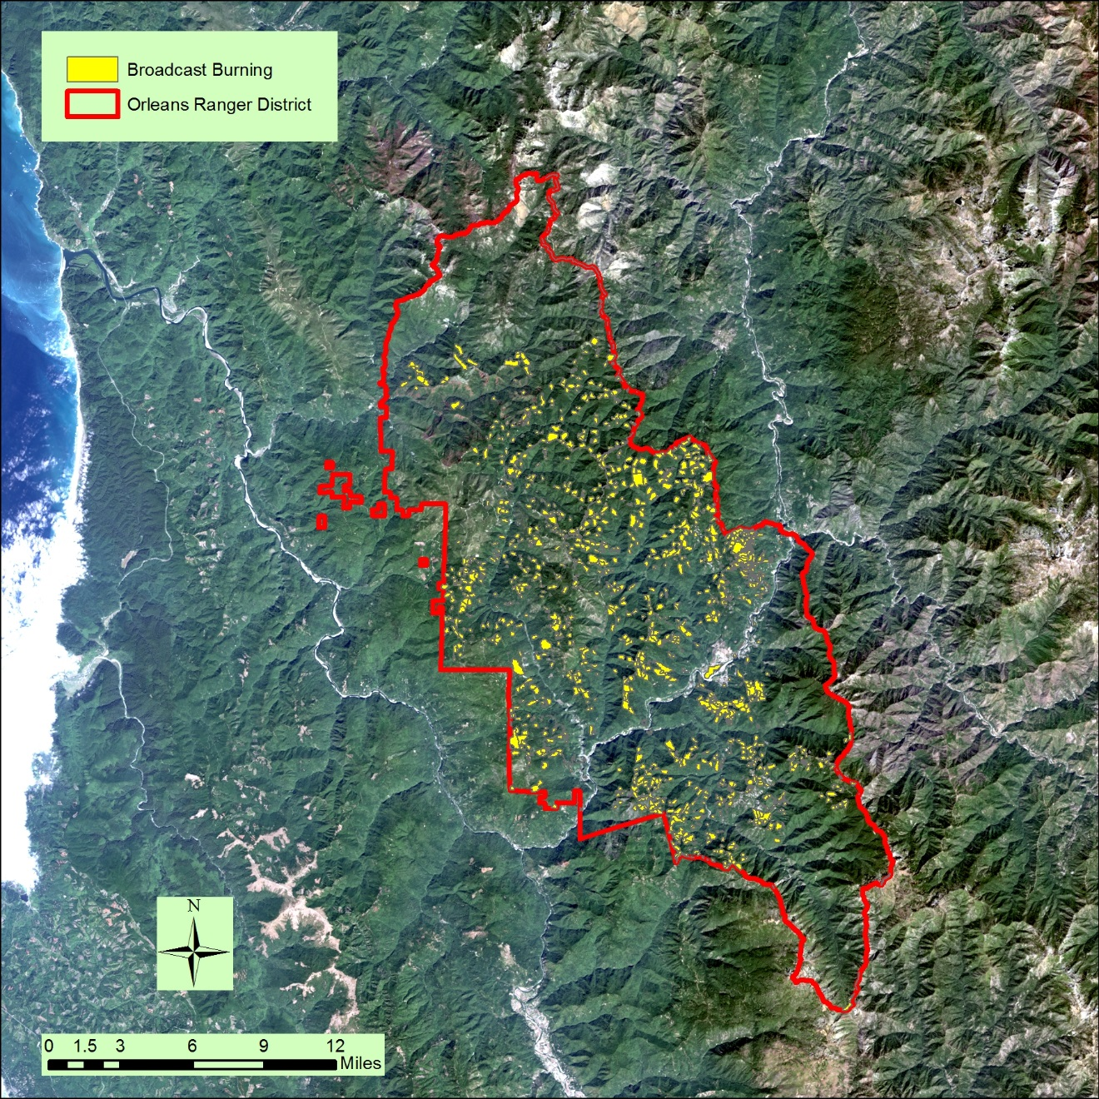
Figure 5. Map Showing Broadcast Burning on the Orleans R.D. 1958-2015 Overlaid on Landsat 8 Image.

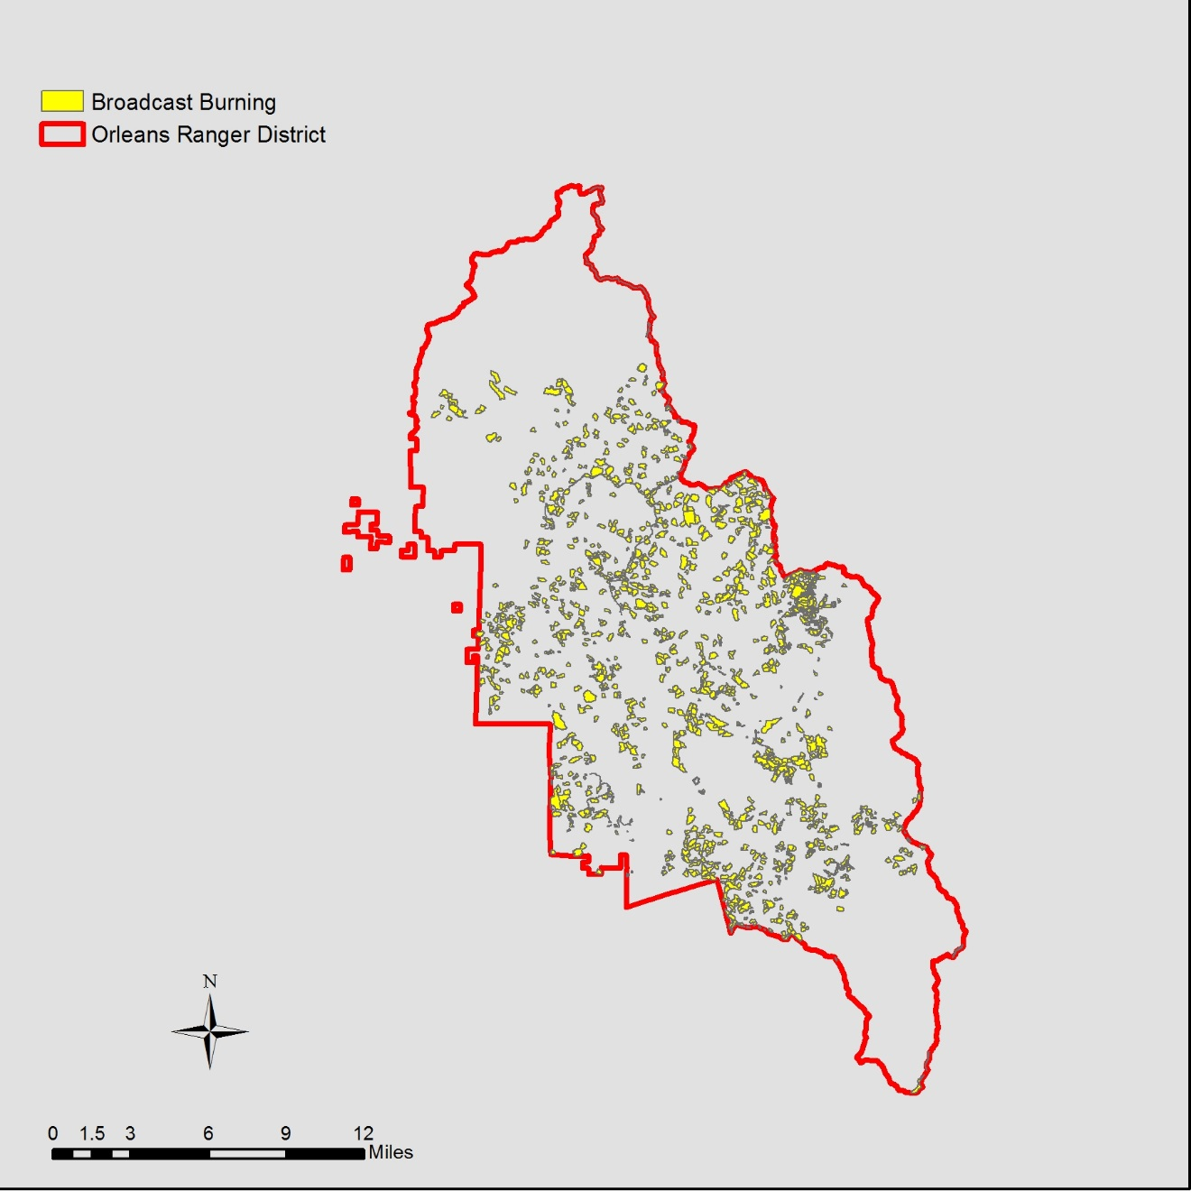
Figure 6. Map showing Broadcast Burning on the Orleans R.D. 1958-2015.

Conclusion
Prescribed fire is a valuable tool for forestland managers. It helps prevent the event of catastrophic wildfires by reducing the available fuel load, improves wildlife habitat and forage, improves nutrient availability to living plants, and helps prevent the outbreak of many forest related diseases. It was used for thousands of years by Native Americans and needs to be re-implemented into many forest management plans. The Orleans R.D. has been using fire as a management tool for quite some time, but the amount of burning remains low because a majority of the public doesn’t know that fire can be used as a tool. Instead the public looks at prescribed fire the same way they look at a wildfire due to a centuries worth of fire suppression and Smokey the Bear anti-fire campaigns. By the year 2020, the number of acres burned should be doubled that of what is listed.

References
Esri, DeLorme, HERE, TomTom, Intermap, increment Corp., GEBCO, USGS, FAO, NPS, NRCAN, GeoBase, IGN, Kadaster NL, Ordnance Survey, Esri Japan, METI, Esri China (Hong Kong), swisstopo, MapmyIndia, and the GIS User Community.
Jennifer Perterson. GIS Specialist. Six Rivers National Forest. Data Acquired, 4th March 2016.
U.S. Department of the Interior. Prescribed Burn Terminology. Oregon/Washington BLM. Web. 26 Apr. 2016.
Zackary Taylor. Fuels Battalion. Six Rivers National Forest. Data Acquired, 14th March 2016.

